|  |
| --- |
| User Manual  Order to cash(User wise) |
| REFERENCE: GW/ERP/USER MANUAL |
|  |
| **Genweb2 Ltd.** |
|  |



|  |
| --- |
|  |

# Document Information

|  |  |
| --- | --- |
| Document Name | User manual for Order to cash(User wise) |
| Document Author | Rashedul Alam |
| Document Version | 1.0 |
| Release Date | 11th April, 2018 |

|  |  |
| --- | --- |
| Review by | Md. Matiar Rahman |
| Review Date | 11th April, 2018 |
| Approved By |  |
| Approval Date |  |

# Document History

|  |  |  |  |  |  |
| --- | --- | --- | --- | --- | --- |
| A=Added, M=Modified, D=Delete | | | | | |
| **Version No** | **Date** | **Section No** | **A/M/D** | **Description of Change** | **Author** |
| 1.0 | 11-April-2018 |  | A | Initial | Rashedul Alam |
|  |  |  |  |  |  |

Contents

A. Document Information 2

B. Document History 2

1. Introduction 5

1.1 Purpose of User Manual 5

2. Customer 5

2.1 Customer creation by Customer Manager 5

3. Products 6

3.1 Product creation by Product Manager 6

4. Customer credit limit 8

4.1 Create customer credit limit by Admin 9

5. Customer Commission 10

5.1 Create customer commission by Sales executive/Head of sales 10

6. Customer commission Approval by Head of Account 11

6.1 Customer commission approval by Head of Account 11

7. Product Sales Pricelist 12

7.1 Create product sales pricelist by Sales user 12

8. Product sales pricelist Approval by Head of Sales 14

8.1 Product sales pricelist Validate by head of sales 14

9. Variant history 17

9.1 Variant history view by Admin 17

10. Sales Order 17

10.1 Create sales order by Sales executive 18

11. Sales order approval by head of sales 19

11.1 Sales order approval by head of sales 19

12. Sales order Validate by Head of Account 19

12.1 Sales order validate by head of account 20

13. Sales order approve by CXO/Director 21

13.1 Sales order approve by CXO 21

14. Delivery Authorization 22

14.1 Create DA by Account head/Account Executive 22

15. Pending DA 23

15.1 Confirm pending DA by Account head 23

16. Delivery order 25

16.1 Delivery order create by accounts head 25

17. Reports 26

17.1 Sales Order reports view by Sales executive 26

17.2 Customer credit limit reports view by Admin 27

17.3 Customer commission reports view by Admin 28

17.5 Product sales pricelist reports view by Sales executive 29

17.5 Delivery authorization reports view by account head 30

17.6 Pending DA reports view by account head 31

17.7 Sales reports view by sales executive 32

17.8 Daily reports view by Admin 33

17.9 Monthly Daily reports view by Admin 34

# 

# 1. **Introduction**

The purpose of this User Manual is to clearly identify the customer requirements and provide a detailed document. The customer will read this document and get a clear view the sales module. It will also help the review team to validate whether the customer requirements have been fulfilled or not.

## Purpose of User Manual

This document will define the clear concept to operate Order to cash process.

# 2. Customer

Customer profile is the place where customer’s information stored.

There will be two types of customer for the sales module.

1. Local Customer

2. Foreign Customer

## 2.1 Customer creation by Customer Manager

Customer will be created/Edited by Customer Manager. Customer can be created company wise.

Customer Manager can create customer using the menu **sales ‣ Customer** and click **Create.**

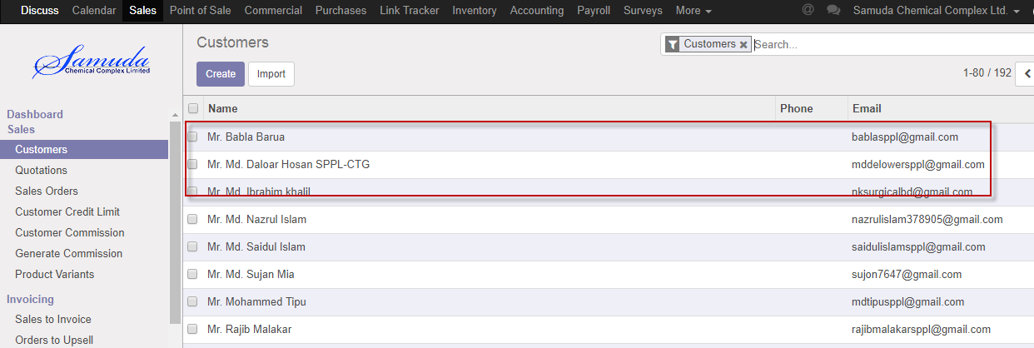

Figure: Customer List view

We need to set the following:-

N**ame**: Enter a customer name.

**Job position:** Enter job position.

**Address:** Enter address.

After entering all information click **Save**.

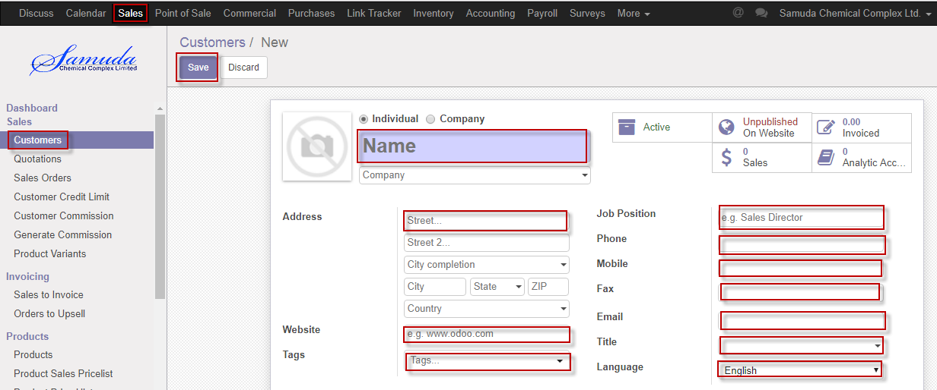

Figure: Create a customer

# 3. Products

Samuda has two types of products. Every feature of Order to cash process will have to go both these category.

1. Basic Product

2. Auxiliary/Performance Product

## 3.1 Product creation by Product Manager

Product will be created/Edited by sales Product Manager.

Finished products will be created by Accounts department

Product Manager can create product using the menu **sales ‣ products** and click **Create.**

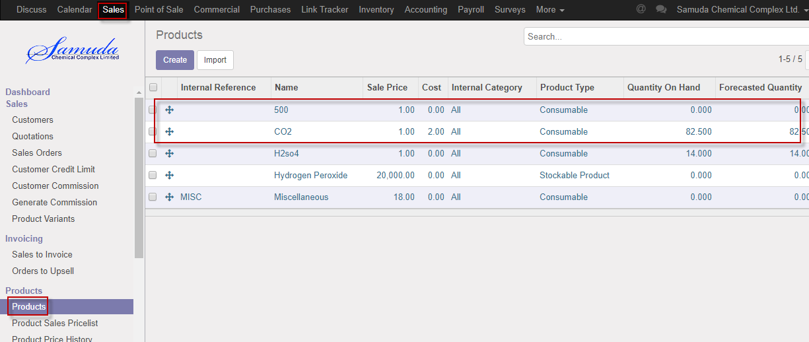

Figure: Products List view

We need to set the following:-

**Product name**: Enter a product name.

**Internal reference:** Select internal reference.

**Internal category:** Select internal category.

**Company:** select Company.

**Can be sold:** Checked.

**Can be purchased:** Unchecked.

**Product variants:** Variants of products should be set using this tab.

**UoM:** Set UoM as MT.

After entering all information click **Save**.

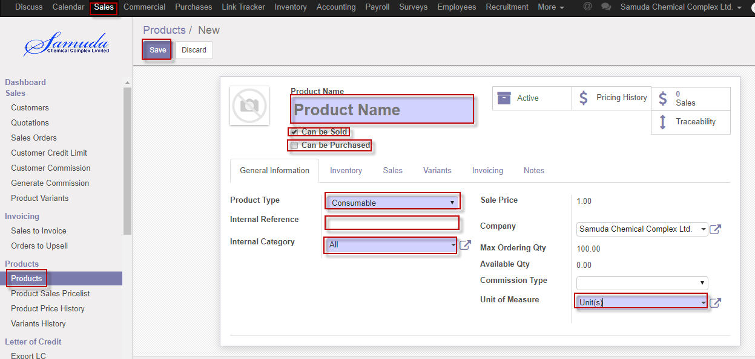

Figure: Create a products

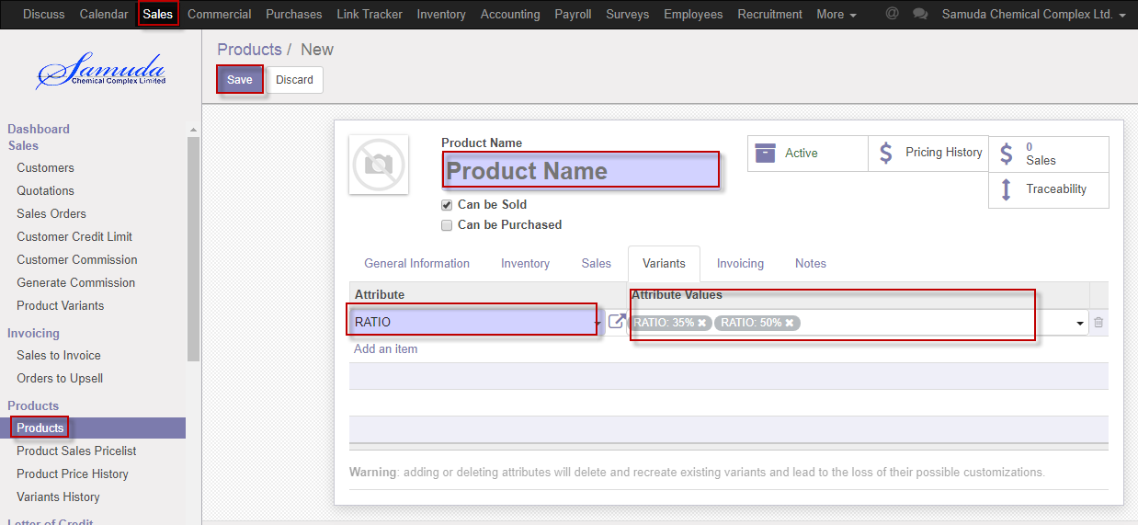

Figure: Create a variants.

# 4. Customer credit limit

Customer credit limit is the maximum amount of credit that a financial institution or other lender will extend to a debtor for a particular line of credit (sometimes called a credit line, line of credit, or a trade line.

If exceed credit limit during Sales order then Second level approval require.

If (Receivable amount +sales order amount) is greater than credit limit then will go second level approval.

## 4.1 Create customer credit limit by Admin

Admin will be created/Edit by customer credit limit.

We can create product using the menu **sales ‣ Customer credit limit** and click **Create.**

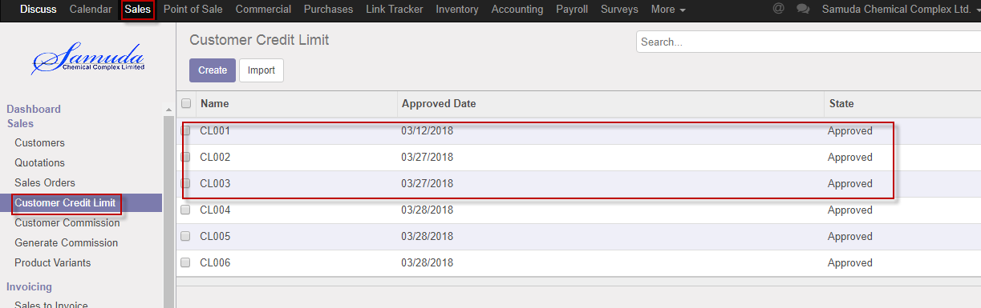

Figure: Customer credit limit List view

We need to set the following:-

**Credit limit**: Enter credit limit.

**Days:** Enter days.

**Customer:** Select customer.

**Generate limit:** press generate limit button.

After entering all information click **Save**.

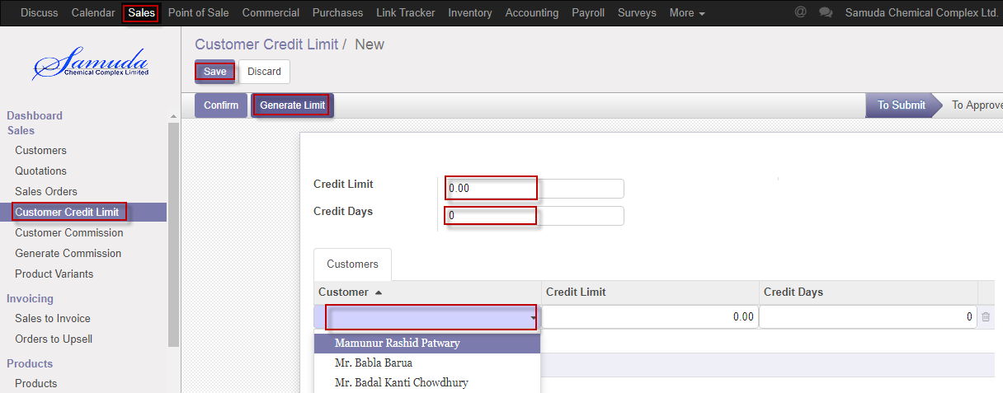

Figure: Create customer credit limit

# 5. Customer Commission

Customer commission request will be initiated by Sales department for example Sales Executive/Head of Sales. It will then wait for the first level approval from Head of Accounts. After the first level approval it will then wait for the second/final level of approval from Management. The request can be rejected from both the approval layers. Customer commission will be set by two types Percentage wise and State value. Commission type if customer then will be percentage wise. And if by product then will be state value.

## 5.1 Create customer commission by Sales executive/Head of sales

Customer commission will be created/Edit by Sales executive/Head of sales

We can create customer commission using the menu **Sales ‣ Customer commission** and click **Create.**

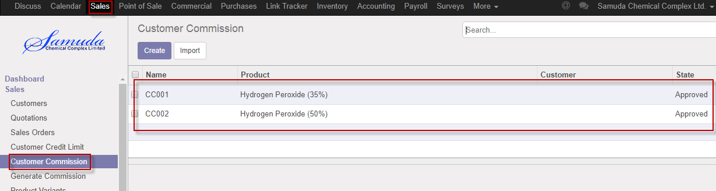

Figure: Customer commission List view

We need to set the following:-

**Commission type**: Select commission type.

**Product:** Select product.

**Customer:** Select customer.

**Value:** Enter new value.

After entering all information click **Save & confirm**.

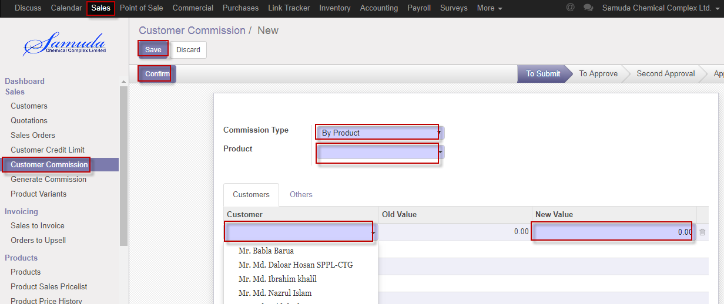

Figure: Create customer commission

# 6. Customer commission Approval by Head of Account

Head of account will approve the customer commission.

## 6.1 Customer commission approval by Head of Account

After apply the customer commission head of account will get the notification. He/she can update commission before approval.

To see the customer commission request use the menu **Sales ‣ Customer commission**

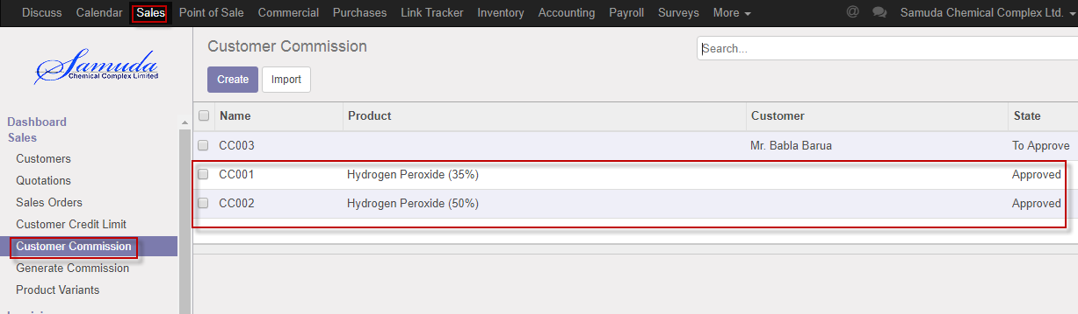

Figure: Customer commission list view

Head of account can approve customer commission. Head of account approve the request by click on **Approve** button 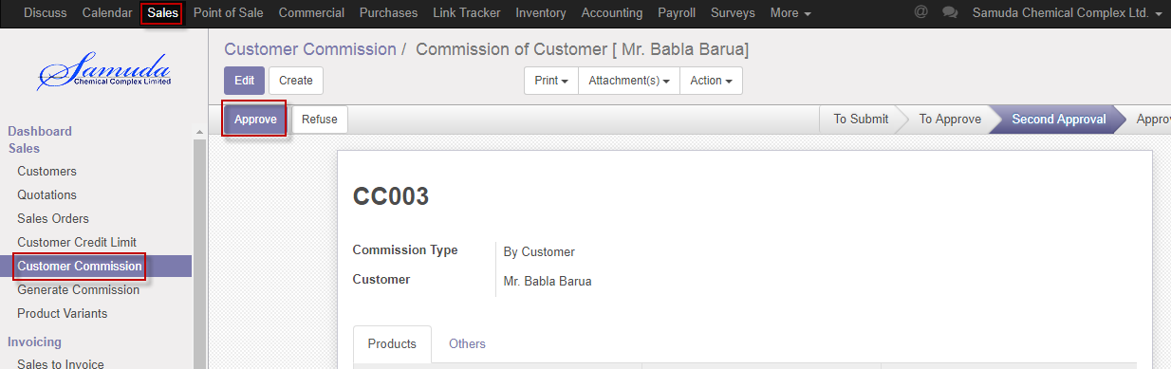

Figure: Customer commission approval

Head of account can refuse customer commission by click **Refuse** Button.

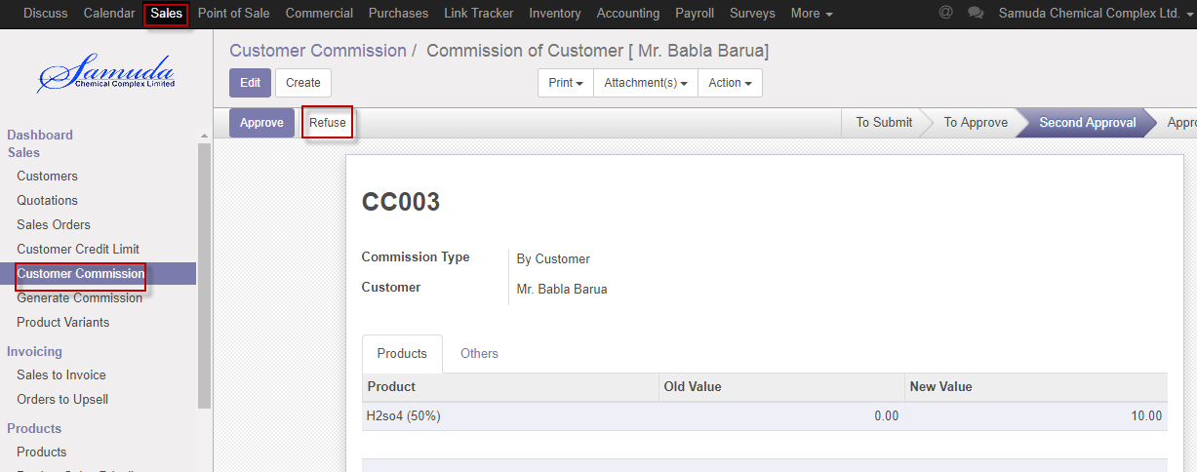

Figure: Customer commission Refuse

# 7. Product Sales Pricelist

This form will introduce new product price replacing the old product price. Management user can be able to change product price & last new price should be countable & old price should have always read only. Latest price will show in product.

Product, packing mode, UoM & Currency wise will calculate in Quotation or Sales order form.

## 7.1 Create product sales pricelist by Sales user

Product sales pricelist will be created/Edit by Admin

We can create product sales pricelist using the menu **Sales ‣ Products>>Product sales pricelist** and click **Create.**

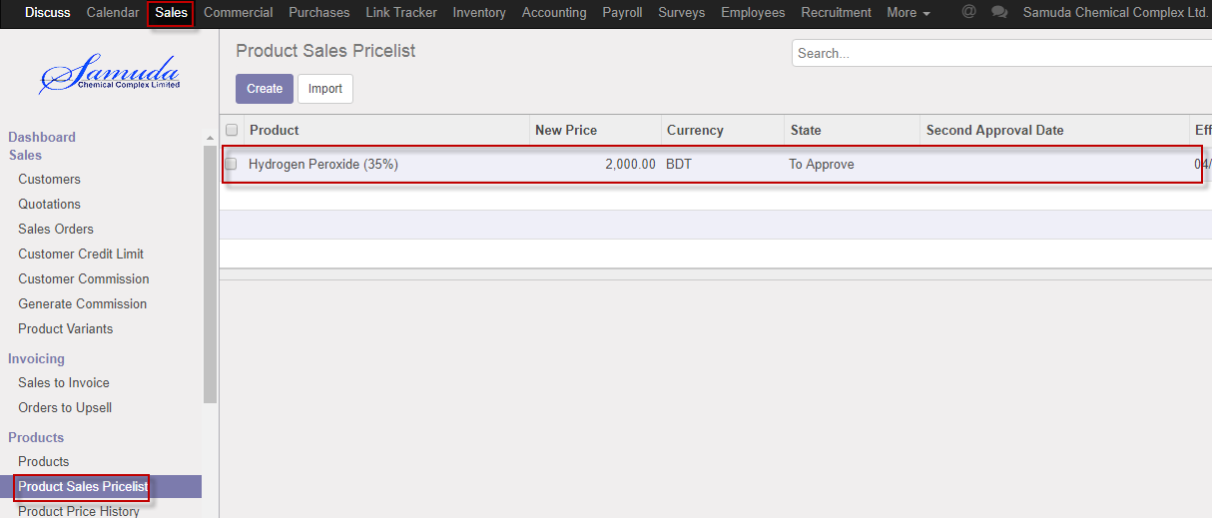

Figure: Product sales pricelist List view

We need to set the following:-

**Product**: Select product.

**Packaging Mode:** Select packaging mode.

**UoM:** Select UoM.

**Currency:** Select currency.

**New price:** Enter new price.

**Effective date:** Select effective date.

After entering all information click **Save & confirm**.

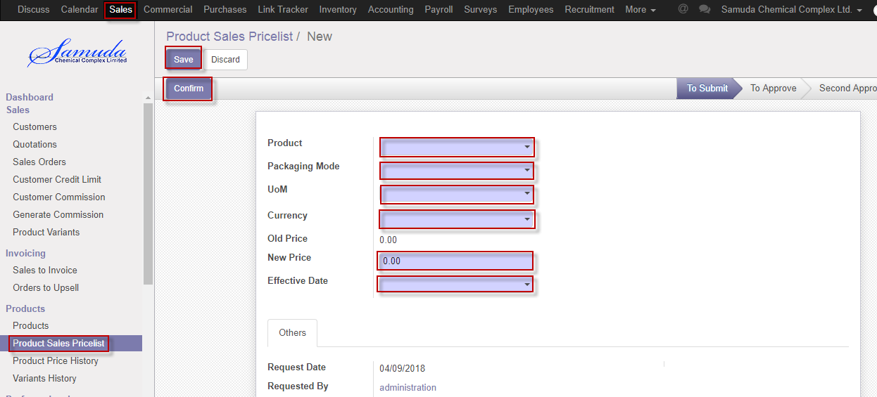

Figure: Create product sales pricelist

# 8. Product sales pricelist Approval by Head of Sales

Product sales pricelist will initiate sales user, head of sales will 1st approve, head of account will validate & CXO will final approve.

## 8.1 Product sales pricelist Validate by head of sales

After confirmation the product sales pricelist head of sales will get the notification. He/she can update price before validate.

To see the product sales pricelist request use the menu **Sales ‣ Products>>Product sales pricelist**

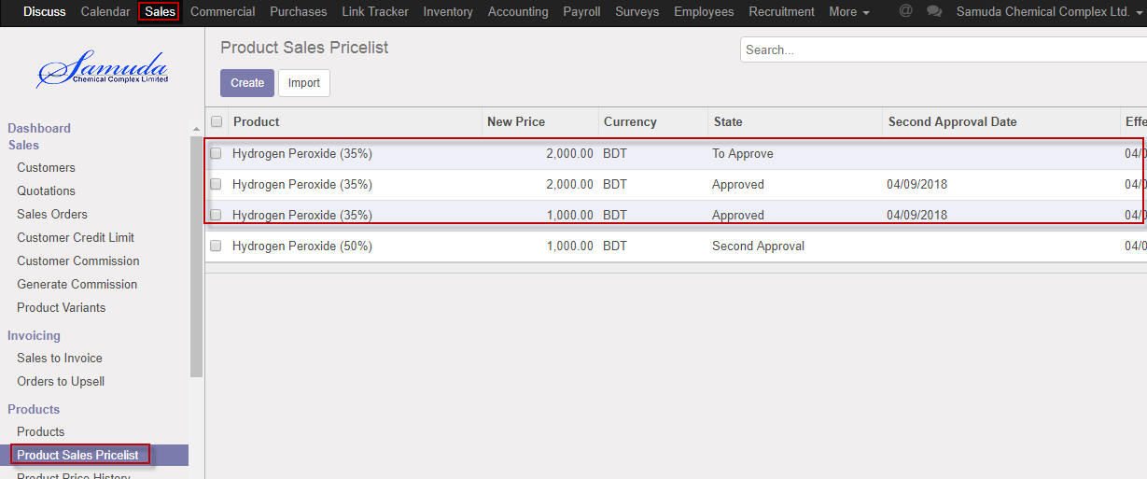

Figure: Product sales pricelist list view

Head of sales can approve product sales pricelist. Head of sales validate the request by click on **Validate** button 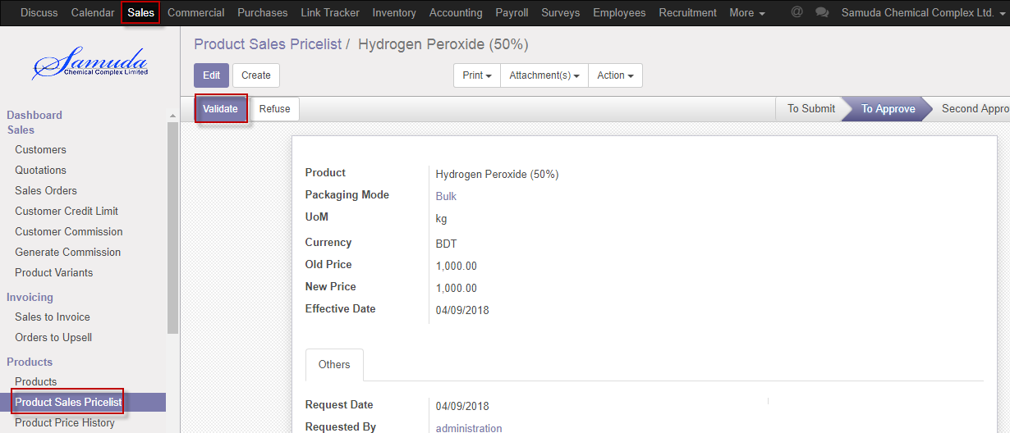

Figure: Sales pricelist validate

Head of account or CXO can approve product sales pricelist. Head of account or CXO approve the request by click on **Approve** button 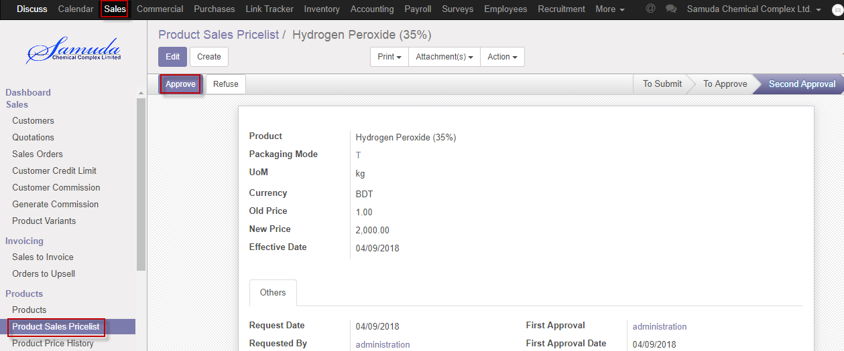

Figure: Sales product pricelist approval

Head of account or CXO can refuse Sales product pricelist by click **Refuse** Button.

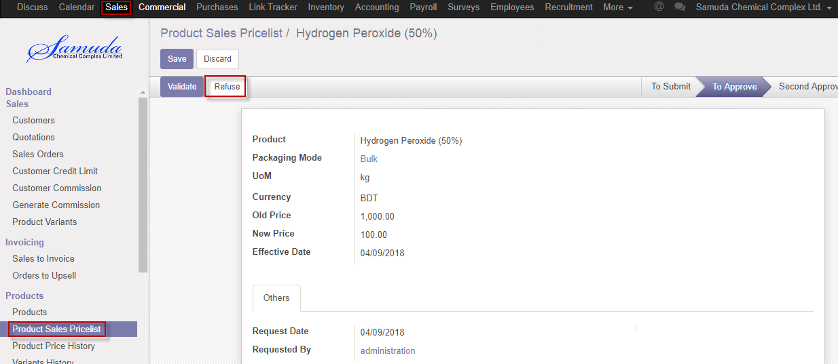

Figure: Sales product pricelist refuse

# 9. Variant history

Everyday 6pm will auto update a scheduler then latest product price history will come auto. Product prices will be automatically updated by a schedules every day at 6PM.

## 9.1 Variant history view by Admin

These prices will be loaded when a sales order is created.

We can view Variant history using the menu **Sales ‣Variant history**

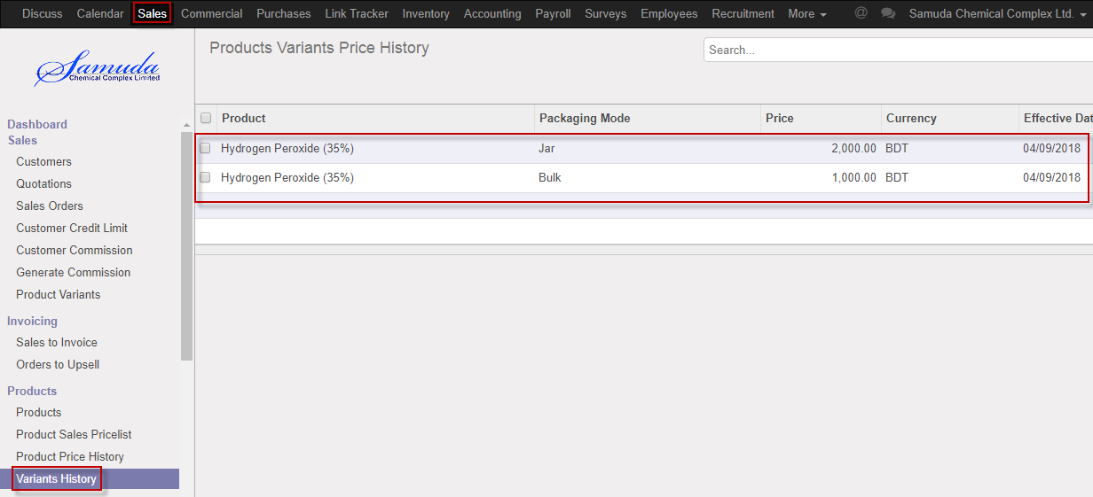

Figure: Variant history view

# 10. Sales Order

The process start from getting an order request from a customer to sales executive. Based on the business nature, Samuda practices three types of Sales Order. This three types of sales order will be created from Sales order type form.

1. Cash

2. Credit Sales

3. LC

## 10.1 Create sales order by Sales executive

Sales order will be created/Edit by Sales executive

We can create sales order using the menu **Sales ‣ Sales order** and click **Create.**

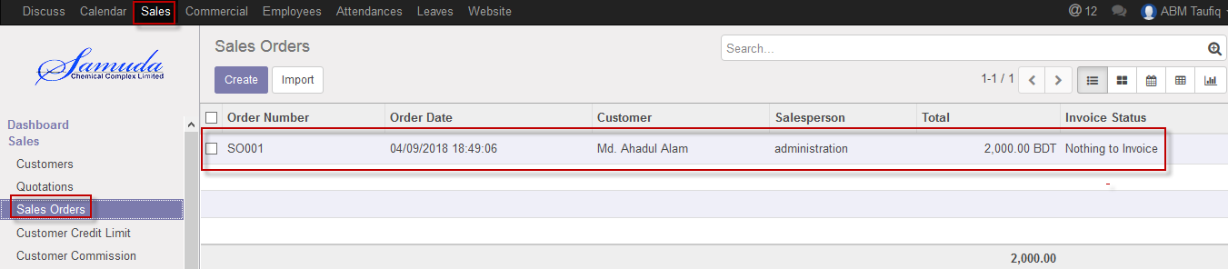

Figure: Sales order List view

We need to set the following:-

**Customer**: Select customer.

**Order date:** Select order date.

**Expiration date:** Select expiration date.

**Type:** Select type.

**Order line:** Select order line.

After entering all information click **Save & Submit**.

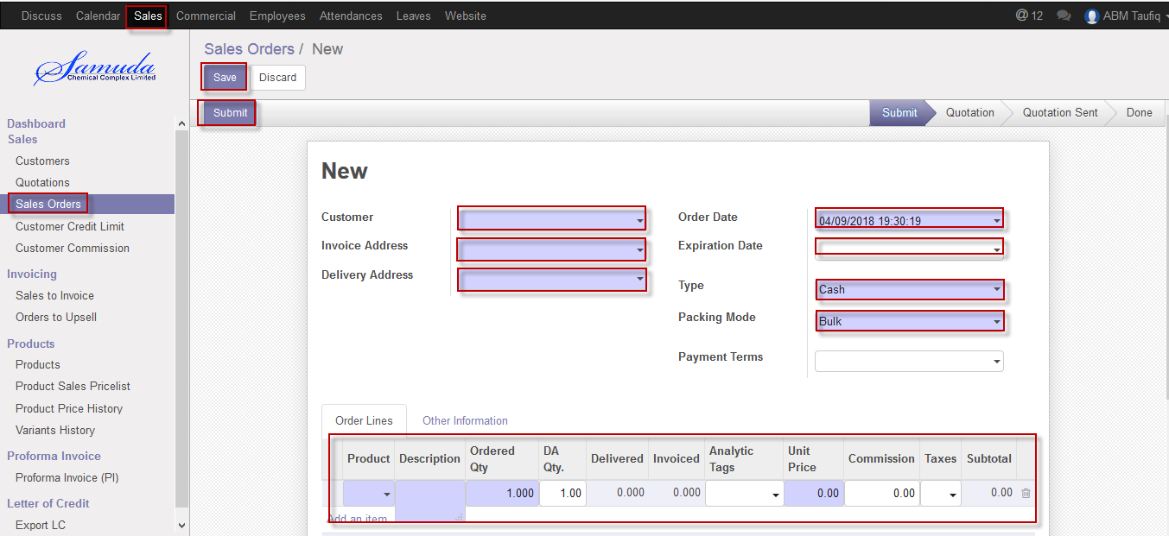

Figure: Create sales order

# 11. Sales order approval by head of sales

Head of sales will approve first approval. If unit price & commission no change then it will done state.

## 11.1 Sales order approval by head of sales

After apply the sales order head of sales will get the notification. He/she can update before approve.

To see the sales order request use the menu **Sales ‣ Sales order**

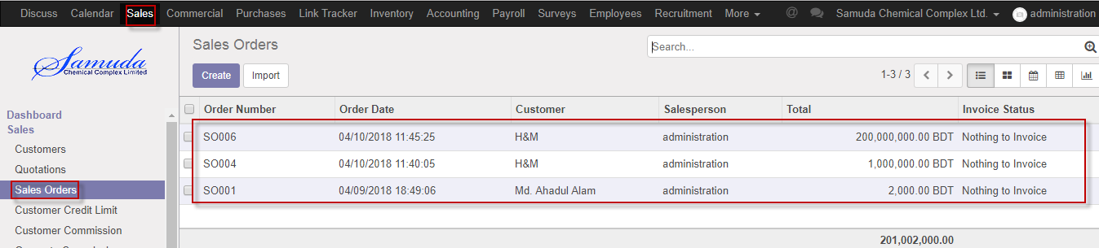

Figure: Sales order list view

Head of sales can confirm sales order. Head of sales confirm the request by click on **Confirm** button 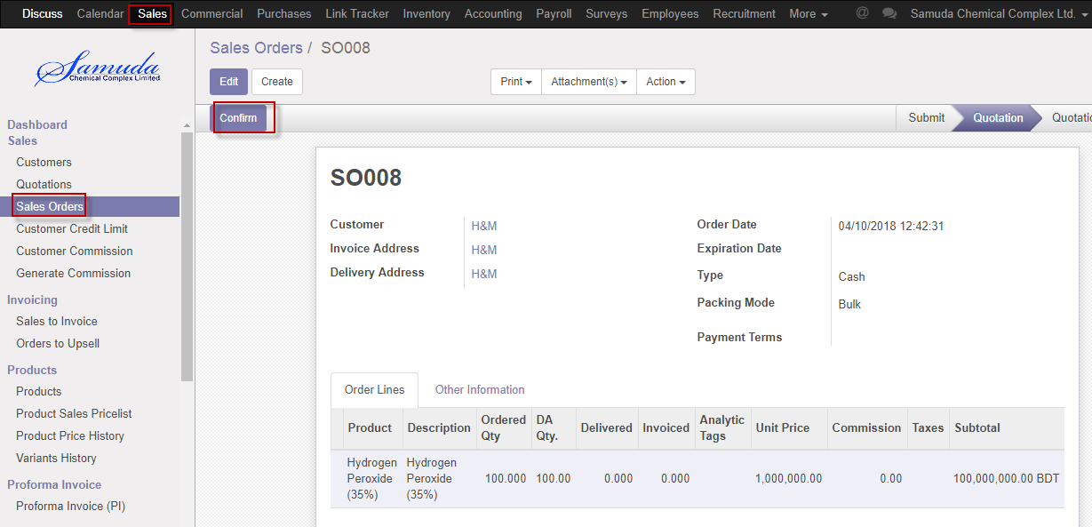

Figure: Sales order confirmed

# 12. Sales order Validate by Head of Account

Sales order will go accounts approval state if unit price and commission will change during the sales order confirmation. Head of account will validate the sales order. Also If total SO amount is less than Actual credit.

## 12.1 Sales order validate by head of account

After confirmation the sales order head of account will get the notification. He/she can update before approve.

To see the sales order request use the menu **Sales ‣ Sales order**

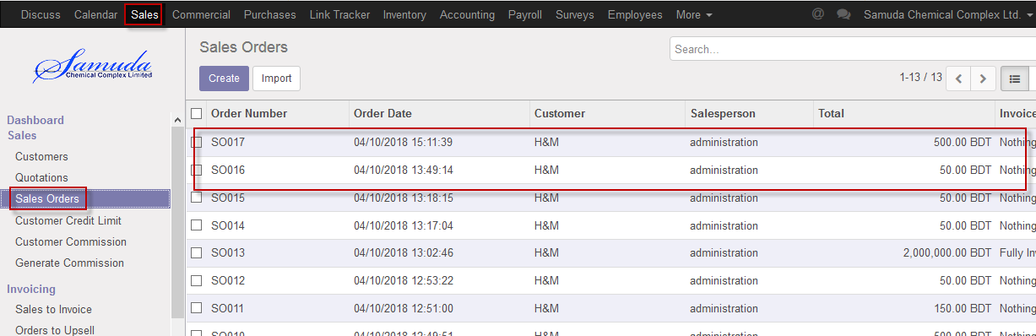

Figure: Sales order list view for validate state

Head of account can validate sales order. Head of account validate the request by click on **Validate** button 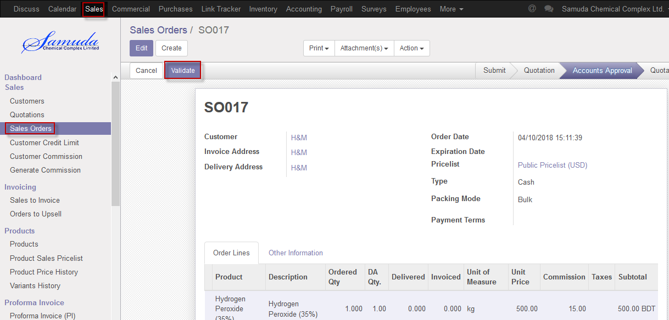

Figure: Sales order Validate

# 13. Sales order approve by CXO/Director

Sales order will go CXO/Director state if unit price and commission will change during the sales order confirmation. CXO will approve the sales order.

## 13.1 Sales order approve by CXO

After validate the sales order CXO will get the notification. He/she can update or cancel before approve.

To see the sales order request use the menu **Sales ‣ Sales order**



Figure: Sales order list view for approve

CXO can approve sales order. CXO approve the request by click on **Approve** button 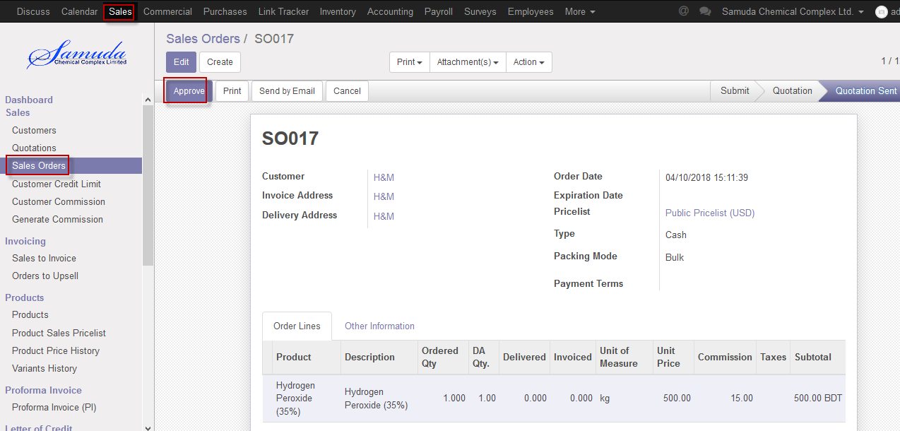

Figure: Sales order approve

Head of account & CXO is capable to cancel sales order by click **Cancel** Button.

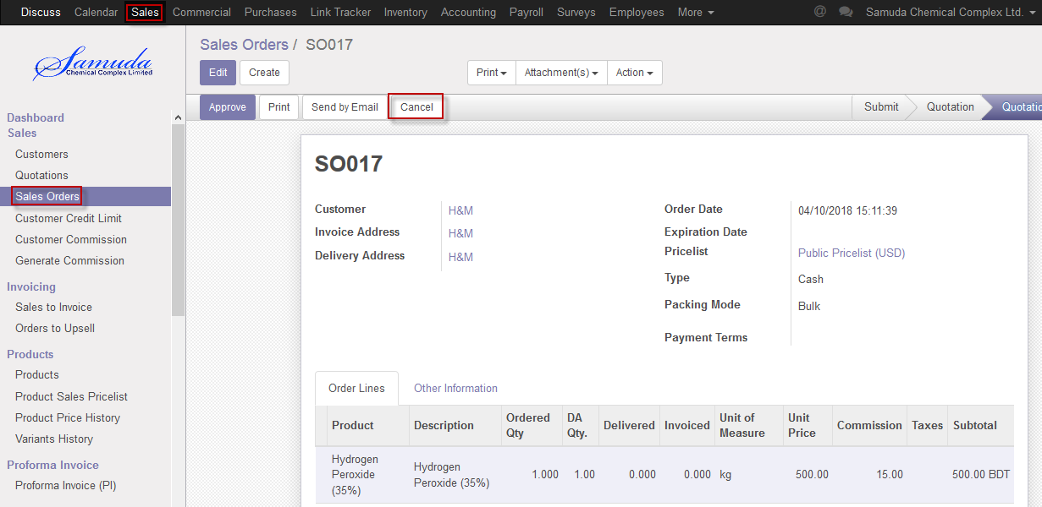

Figure: Sales order cancel

# 14. Delivery Authorization

Account Executive will create and confirm the delivery authorization.

## 14.1 Create DA by Account head/Account Executive

DA will be created and confirm by Account head/Account executive

We can create DA using the menu **Sales ‣ Delivery authorization** and click **Create & confirm.**

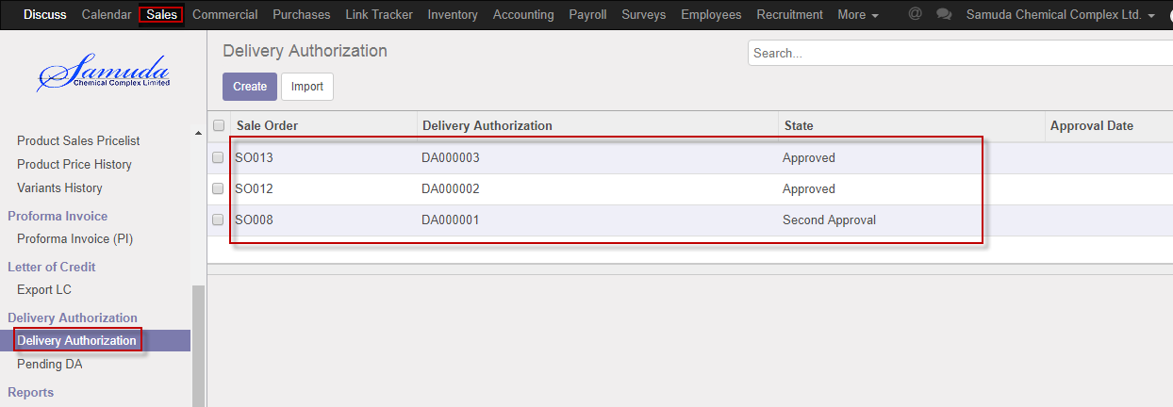

Figure: DA List view

We need to set the following:-

**Sales order**: Select sales order .All info will come auto after select sales order.

After select all information click **Save & Confirm**.

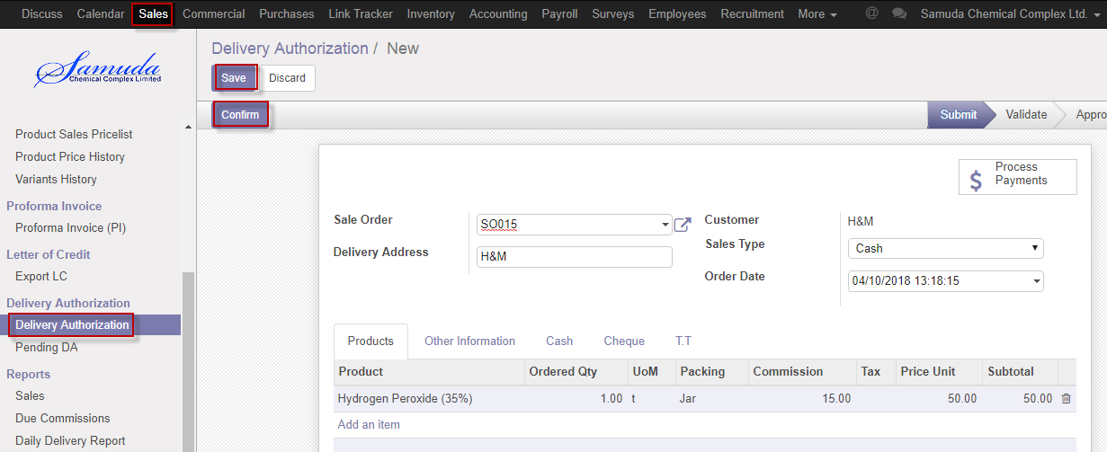

Figure: Create DA

# 15. Pending DA

Sales order which is in approved state but no delivery auth is done yet, will come under this menu item.

## 15.1 Confirm pending DA by Account head

Pending DA will confirm by Account head

We can create DA using the menu **Sales ‣ Pending DA** and click C**onfirm.**

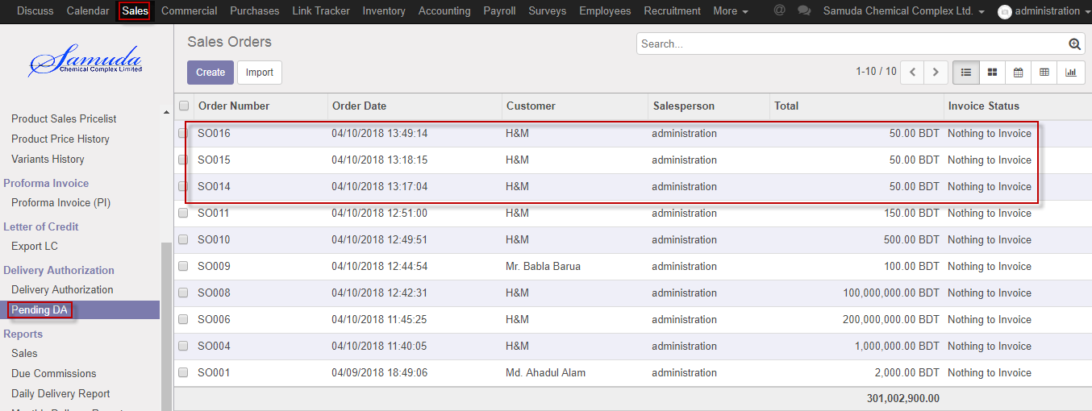

Figure: Pending DA List view

We need to set the following:-

**Delivery Authorization**: After click delivery authorization button pending DA will ready for confirm state.

After set all information click **Save & Confirm**.

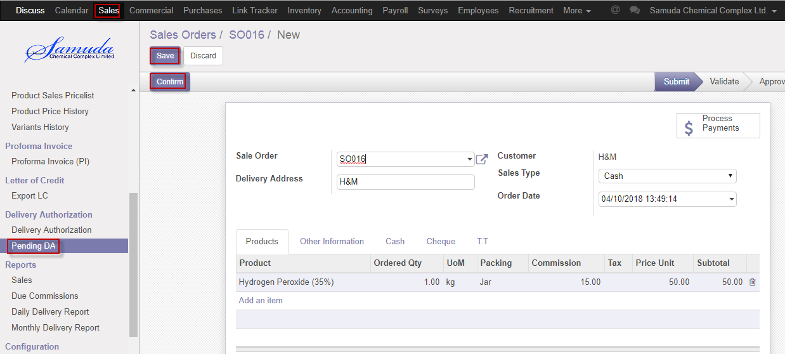

Figure: Confirm Pending DA

After confirm DA will ready for Validate.

After set all information click **Validate**.

Account head is capable to refuse click Refuse button

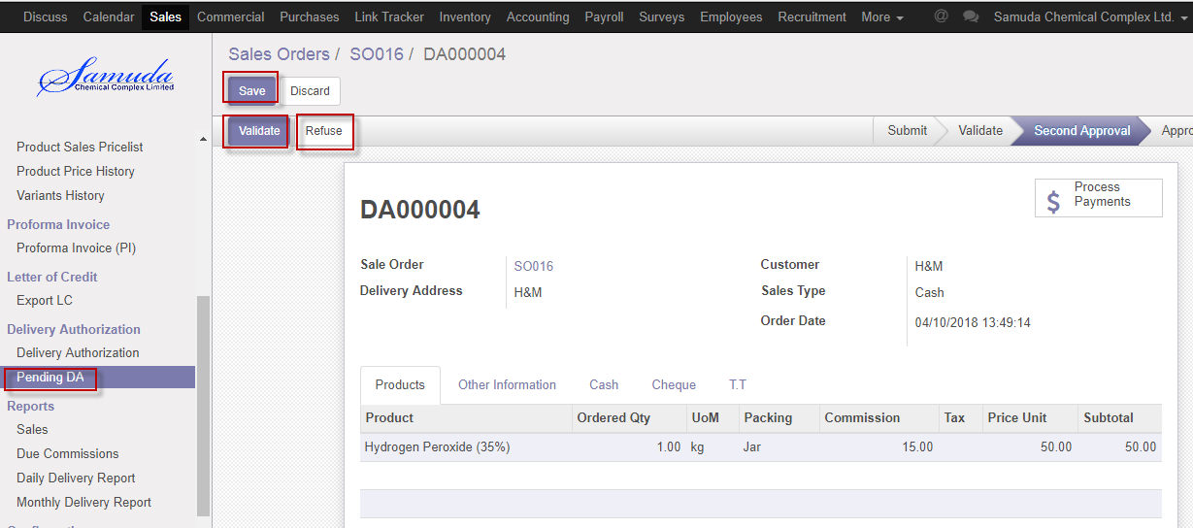

Figure: Validate & Refuse DA

# 16. Delivery order

A delivery order before state of stock picking and after state of delivery authorization. Accounts executive or Accounts head will generate & confirm the delivery order. Delivery order will not go for Stock picking until DO confirmation.

## 16.1 Delivery order create by accounts head

Delivery order will be created/Edit by account head.

We can create delivery order using the menu **sales ‣ products** and click **Create.**

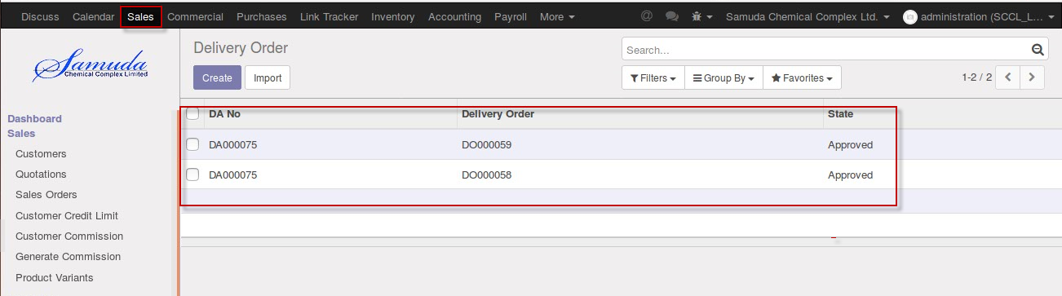

Figure: Delivery order List view

We need to set the following:-

**DA no**: Select DA no. after DA no all information will come auto.

After come all information click **Save & Confirm**.

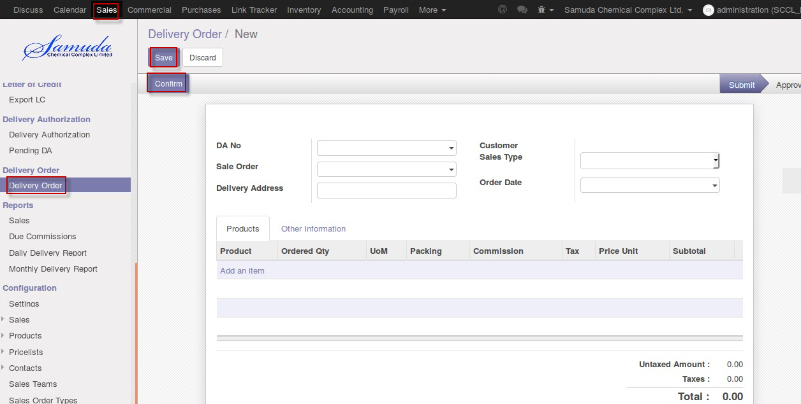

Figure: Create a delivery order

# 17. Reports

In sales module reports contain all the sales related information. Reports document containing information graphic, or tabular form, prepared on ad hoc, periodic, recurring, regular, or as required basis.

## 17.1 Sales Order reports view by Sales executive

To see the sales order reports use the menu **Sales ‣Select sales order from list>** **Print>Quotation**

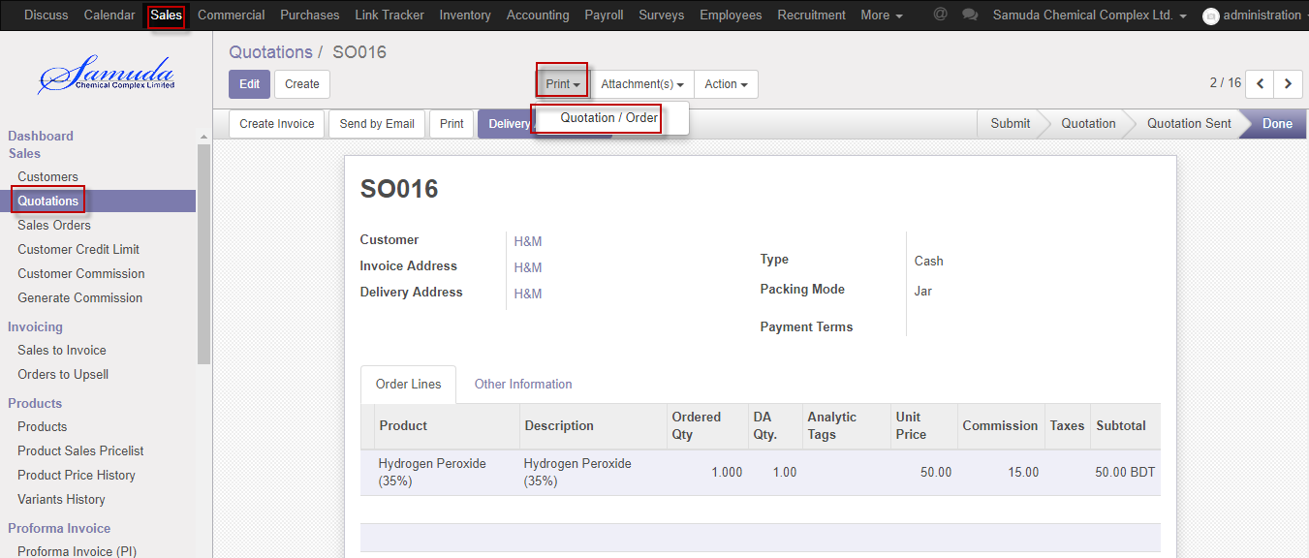

Figure: Sales order reports print view

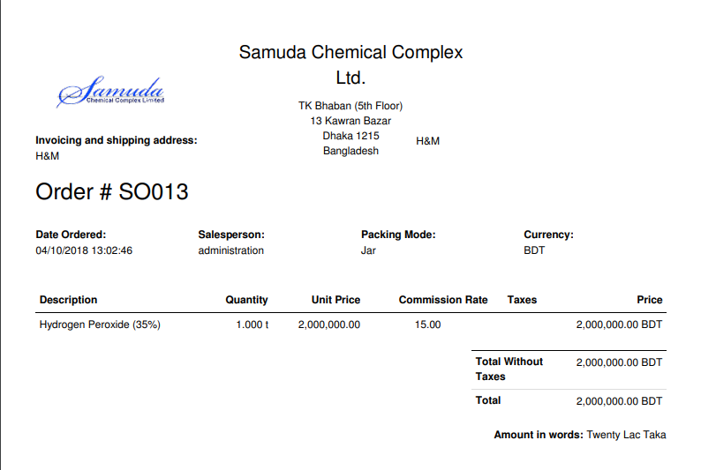

Figure: Sales order reports PDF format

## 17.2 Customer credit limit reports view by Admin

To see the customer credit limits reports use the menu **Sales ‣select customer credit limit from list>** **Print>Credit limit summary**

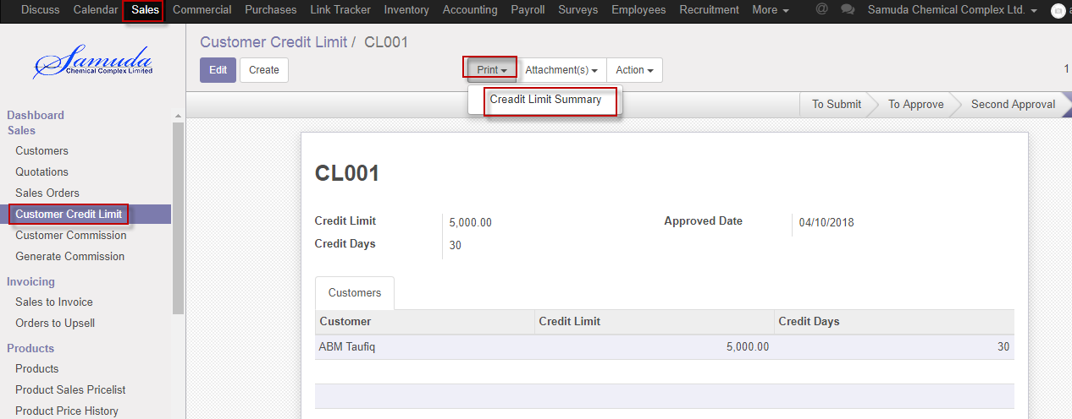

Figure: Customer credit limit reports print view

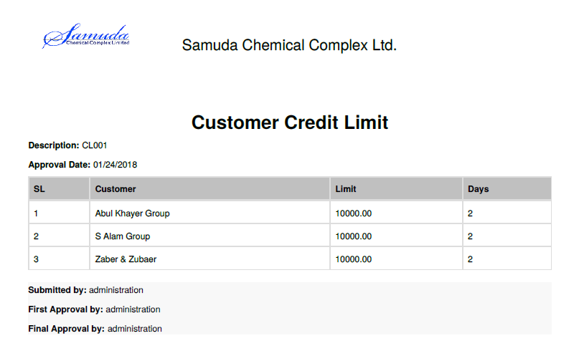Figure: Customer credit limit reports PDF format

## 17.3 Customer commission reports view by Admin

To see the customer commission reports use the menu **Sales ‣select customer commission from list>** **Print>Commission report**

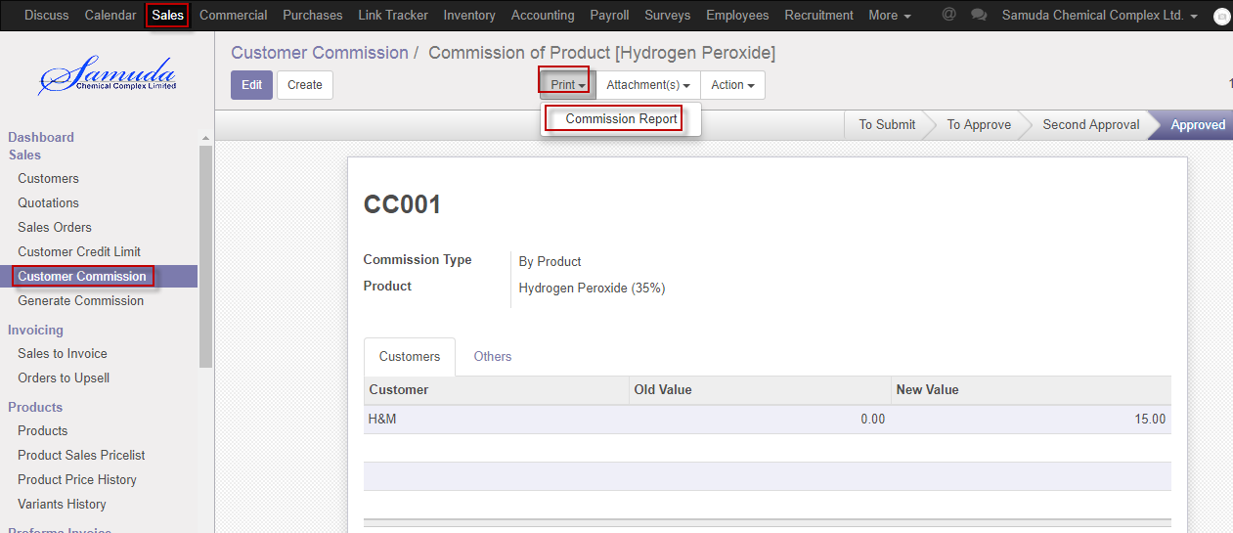

Figure: Customer commission reports print view

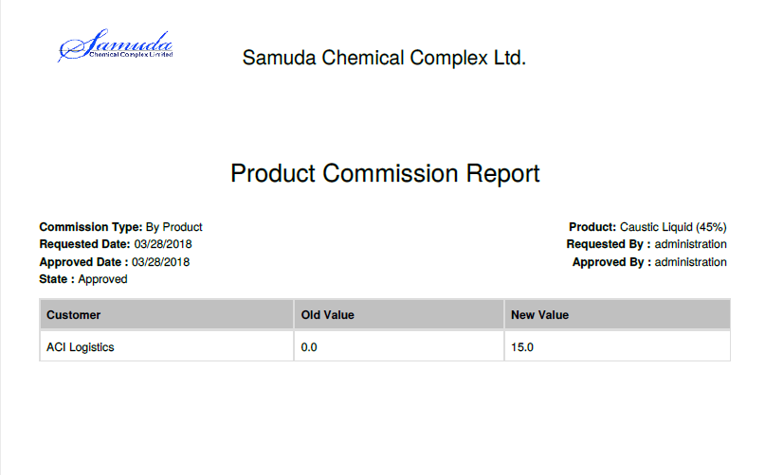

Figure: Customer commission reports PDF format

## 17.5 Product sales pricelist reports view by Sales executive

To see the product sales pricelist reports use the menu **Sales ‣select product sales pricelist from list>** **Print>Product pricelist**

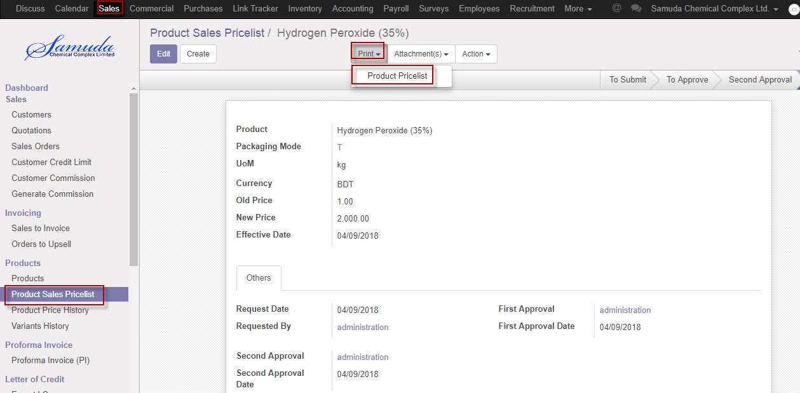

Figure: Product sales pricelist reports print view

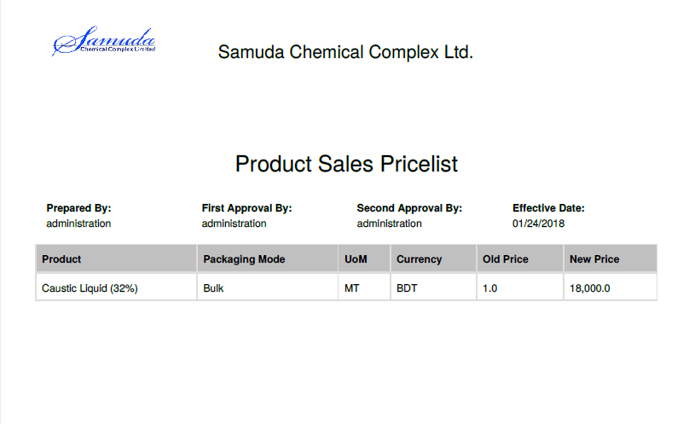

Figure: Product sales pricelist PDF format

## 17.5 Delivery authorization reports view by account head

To see the Delivery authorization reports use the menu **Sales ‣select Delivery authorization from list>** **Print>Delivery authorization**

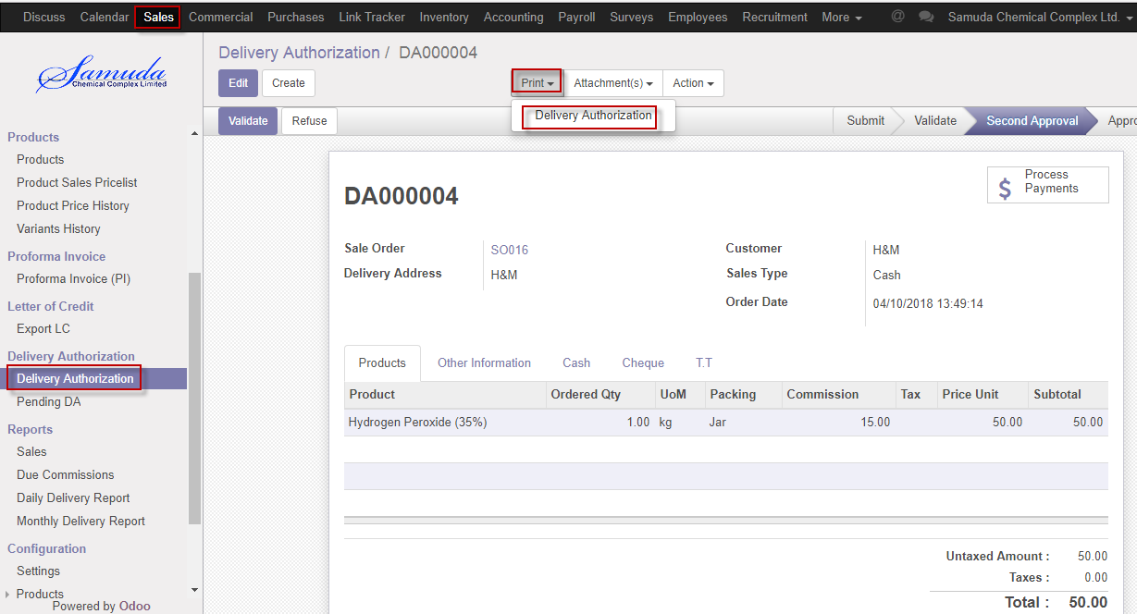

Figure: Delivery authorization reports print view

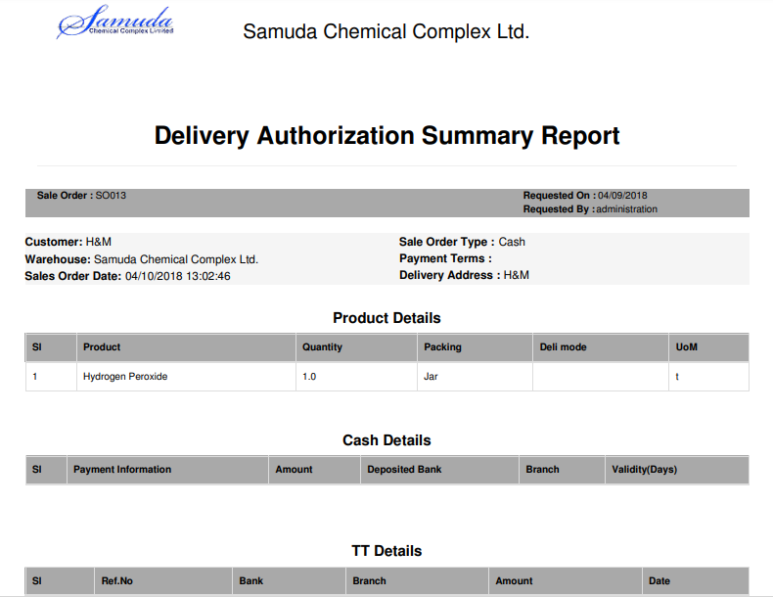

Figure: Delivery authorization reports PDF format

## 17.6 Pending DA reports view by account head

To see the pending DA reports use the menu **Sales ‣select pending DA from list>** **Print>Quotation/order**

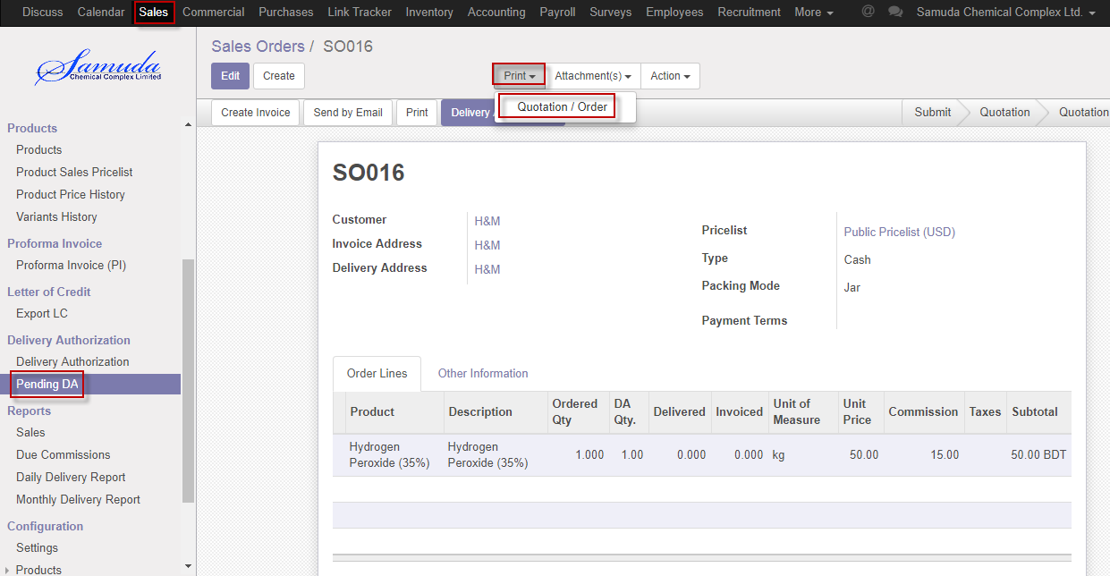

Figure: Pending DA reports print view

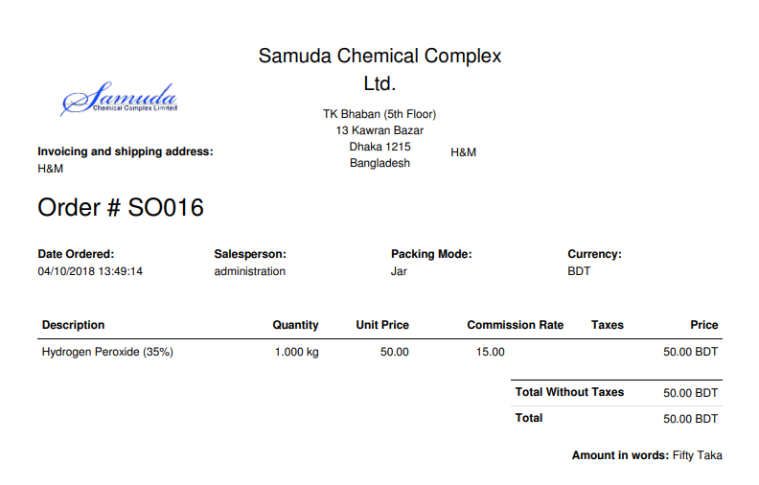

Figure: Pending DA reports PDF format

## 17.7 Sales reports view by sales executive

To see the Sales reports use the menu **Sales ‣Reports>Sales** >>Click to expand and Select an option to View reports

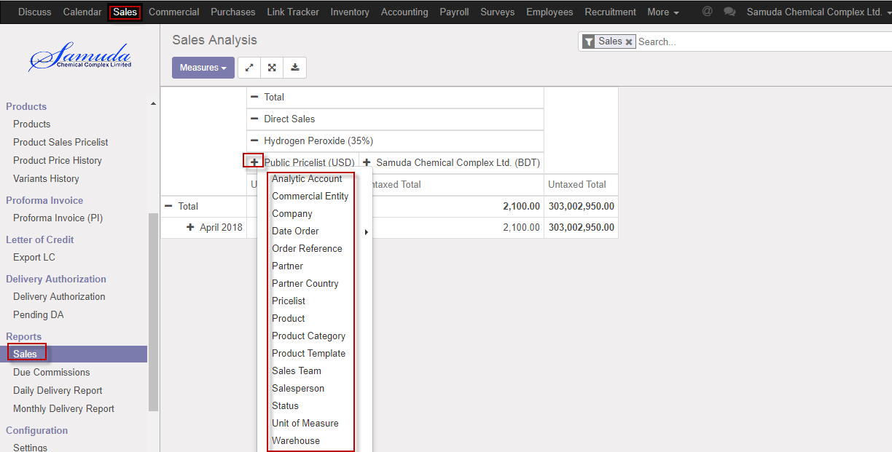

Figure: Sales print view

## 17.8 Daily reports view by Admin

To see the daily reports use the menu **Sales ‣Reports>** **Daily reports**

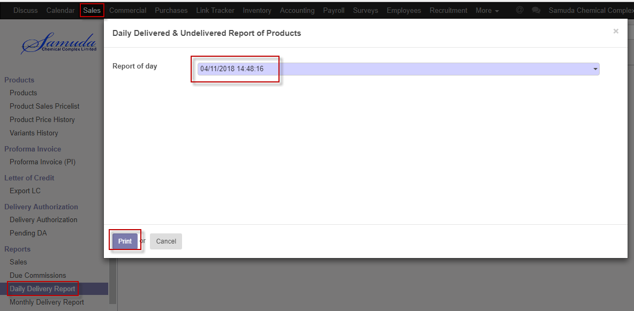

Figure: Daily reports print view

We need to set the following:-

**Report of day**: Select reports of day.

**A**fter entering all information click **Print**.

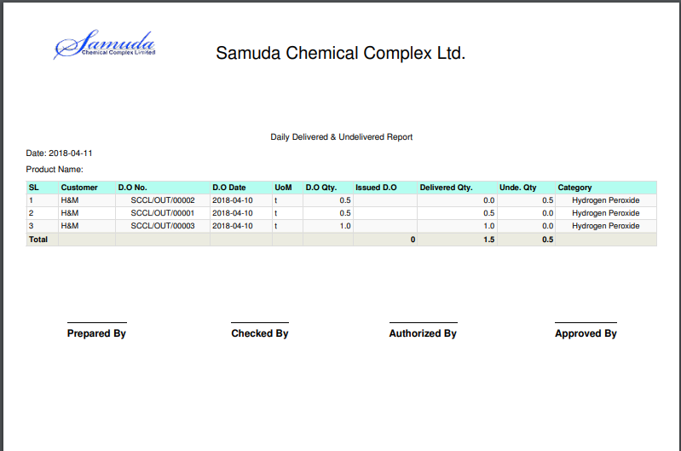

Figure: Daily reports PDF format

## 17.9 Monthly Daily reports view by Admin

To see the Monthly daily reports use the menu **Sales ‣Reports>Monthly Daily reports**

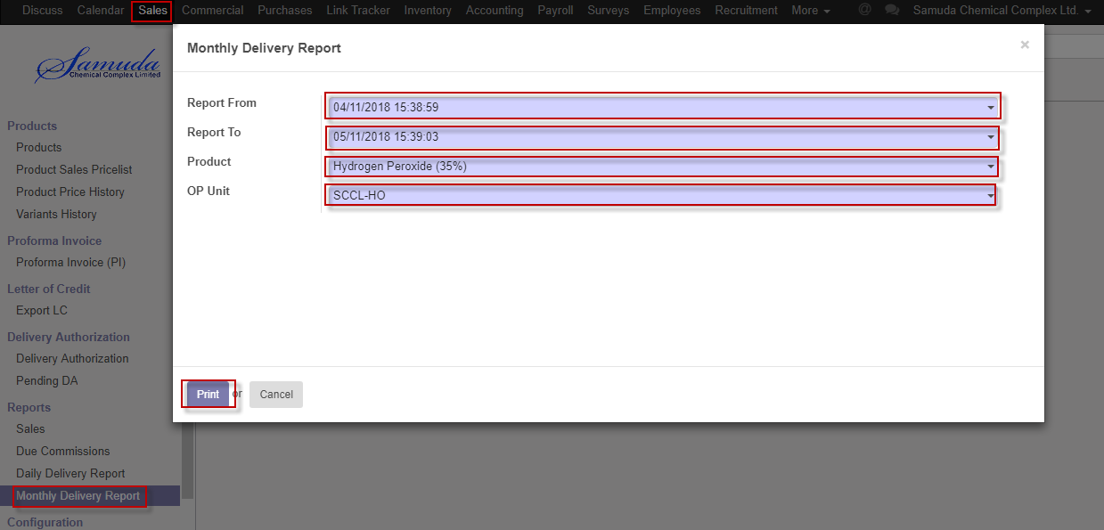

Figure: Monthly daily reports print view

We need to set the following:-

**Report from**: Select report from.

**Report To**: Select report to.

**Product**: Select product.

**OP unit**: Select OP unit.

**A**fter entering all information click **Print**.